Northern Neck Technical Center
Nurse Aide Course Calendar 2020-2021

Week | Topics | Assignments | Skills/Competencies
Welcome to Nurse Aide  Weeks 1,2,3  August 17-September 4  *175.00*  DUE 9/18 | - Orientation  - Syllabus  - Canvas Training  - Teambuilding/Icebreakers  - Review of Student Handbook  - Virtual Field Trip to RCC  - Virtual Tour The Orchard  CPR Certification | - Complete all required paperwork signed by 9/18 | Classroom hrs Lab hrs  8
Unit 1  Weeks 4 &5  September 8-18 | Chapter 1: The Health Care System (pp. 3-14)  Chapter 2: The Nursing Assistant’s Job and understanding and respecting client’s rights (pp. 19-38)  Chapter 3: Professionalism and Job-Seeking Skills (pp. 43-56)  *legal and regulatory aspects of nurse aides | Unit Test 1: Chapters 1, 2, & 3 | Classroom Lab  12  8
Unit 2  Weeks 6 & 7  September 21-October 2 | Chapter 4: Communication and Interpersonal Skills (pp. 60-70)  Chapter 5: Those We Care For (pp. 77-90)  Chapter 10: Overview of Long TermCare (pp.221-228  Chapter 11: The Long Term Care Resident including admission, transfer, and discharge. (pp. 231-242) | Unit Test 2: Chapters 4, 5, 10 & 11  HOSA intro  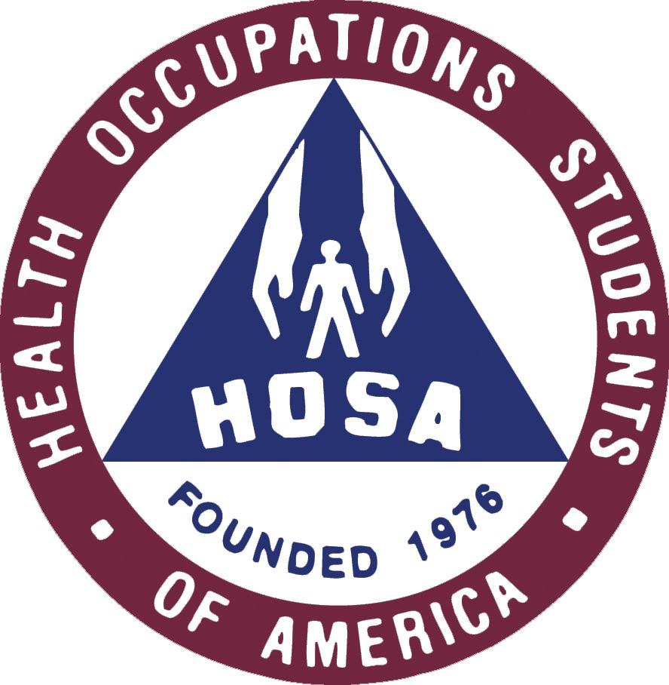 | Classroom Lab  12  4
Unit 3  Weeks 8&9  October 5-16 | Infection Control and Safety  Chapter 13: Infection Control (267-290)  Chapter 14: Workplace Safety (pp. 300-315)  Chapter 15: Patient and Resident Safety including preventing falls (pp. 320-33  Chapter 16: Basic First Aid, Safety and Emergency Care procedures, including dealing with obstructed airways | Unit Test 3: Chapters 13, 14, 15 & 16 | Classroom Lab  6 6  6  6  8 4
Unit 4  Weeks 12&13  October 19-30 | Basic Nursing Skills  Chapter 6: The Patient’s or Resident’s Environment (pp. 94-104)  Chapter 19: Bedmaking (pp. 407-414)  Chapter 20: Measuring and Recording Vital Signs Height & Weight (pp.421-436)  Chapter 27:Assisting With Comfort (pp. 615-619) | Unit Test 4: Chapters 6, 19, 20 &  27 | Classroom Lab  16 8
Unit 5  Weeks 14&15  November 2-13 | Personal Care  Chapter 21: Assisting with Hygiene (pp. 455-471)  Chapter 23: Assisting With Grooming (pp. 506-518) | Unit Test 5: Chapters 21 & 23 | Classroom Lab  30 24
Unit 6  Weeks 16&17  November 16-27 | Chapter 24: Assisting With Nutrition (pp. 535-555)  Chapter 25: Assisting With Urinary Elimination (pp. 564-580)  Chapter 26: Assisting With Bowel Elimination (pp. 594-604) | Unit Test 6: Chapters 24, 25 & 26  Thanksgiving Break Nov. 25-27 | Classroom Lab  6.5 8.25
Unit 7  Weeks 18&19  November 30-December 11 | Chapter 17: Assisting With Repositioning and Transferring (pp. 359-368)  Chapter 18: Assisting With Exercise (pp. 389-393)  Chapter 22: Preventing Pressure Ulcers and Assisting with Wound Care (pp. 489-499 | Unit Test 7: Chapters 17, 18 & 22 | Classroom Lab  6 9.25
Unit 8  Weeks 20 & 21  December 14-25 | Chapter 12:Caring for People with Dementia (pp.246-263)  Chapter 29: Caring for People With Developmental Disabilities (pp. 650-655) | Unit Test 8: Chapters 12 & 29  Winter Break Dec. 21-Jan. 1 | Classroom Lab  6
Unit 9  Weeks 22 & 23  January 4-15 | Basic Restorative  Chapter 9: Rehabilitation and Restorative Care while promoting client’s independence (pp. 207-213)  Chapter 32: Caring for People who are Having Surgery (pp.674-692) | Unit Test 9: Chapters 9 & 13 | Classroom Lab  12 4
Unit 10  Weeks 24 & 25  January 18-29 | Chapter 28: Caring for People who are Dying (pp. 632-642)  Chapter 30: Caring for People With Cancer (pp.659-664)  Chapter 31:Caring for People With HIV/AIDS (pp.667-671)  Mental Health and Substance Abuse | Unit Test 10: Chapters 28, 30, 31 | Classroom Lab  12  Mental health and opioid abuse  Classroom  16
February 1-April 2  Spring Break April 4-9  April 12-16 | State Board Review  State Board Test  Medical Terminology  Chapter 33: Caring for People in the Home Environment (pp.694-708)  Course wrap up/clean up | CLINICALS  Skills Labs  Home Care Review | Classroom Lab  2
April 19-23 1st Clinical group-completed  April 26-30 2nd Clinical group-completed  May 3-7 3rd Clinical group-completed  May 8&10-13 4th Clinical group-completed | Nurse Aide Skills Labs  &  CLINICALS  Carrington Place of Tappahannock  7:30a.m.-3:30p.m. | State Board Review  State Board Test  Course Completion and Ceremony-May 28, 2021 | Clinical groups:  Each day 6:40am-3:30pm=8hrs  5 days X 8 hrs – Total 40hrs  One 15min break  One 30 min Lunch

